**Unit One Review Chris W.**

Section 5.1

Given a quantity function *G(t*) and its ROC function *g*(*t*),

Accumulated change in *G(t*) = the signed area of a region between *g*(*t*) and the *t*-axis between *a* and *b*.

Relationship between function *G(t*) and the ROC function *g*(*t*), Relative Max, Relative Min, Inflection points, concavity. See you can sketch this rate of change function’s accumulation.

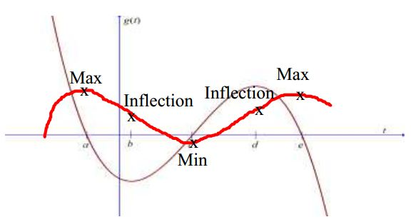

Section 5.2

Approximating area under a curve using rectangles.

Consider the following: We are estimating the area **under the curve** between 0 and __16__using left rectangles.

|  |  |
| --- | --- |
| = ____64_____ |  |

The Index is initially set at zero. The notation tells us to evaluate the function at 4 times the value of the index for the height, and multiply that height by (the width of the rectangle). The index *i* then is increased by one to 1. Suppose the function is *f*(*x*) = *x* - 2. Use the sigma notation by filling out the chart below to estimate the area under the curve:

|  |  |  |  |  |  |  |
| --- | --- | --- | --- | --- | --- | --- |
| Index (*i*) | 0 | 1 | 2 | 3 |  |  |
| 4*xi* | 0 | 4 | 8 | 12 |  |  |
| *(height) f*(4*xi*) | -2 | 2 | 6 | 10 |  |  |
| *height x width* | -2 x 4 = -8 | 8 | 24 | 40 |  |  |
| area | -8 | 0 | 24 | 64 | Sum= | 64 |

 We can get the exact area by using the integral. What is the value of *b*? 16

Find the exact area.

 0 + 96 = 96

Section 5.3

Given a function *f*(*t*), which is a rate of change function.

The accumulation function, denoted by *A*(*x*) = gives the accumulation of the signed area between the *x*-axis and the graph of *f* from *a* to *x*.

We know that *A*(*x*) is equal to zero at __a___

Section 5.4 and 5.5

The Fundamental Theorem of Calculus says that if you take the integral of a function and then take its derivative, you will get the same function back.

 also: 

Derivative and Antiderivative Formulas

|  |  |  |  |  |
| --- | --- | --- | --- | --- |
| Rule | Function | Derivative | Function | Antiderivative |
| power | *f*(*x*) = *x*3 | *3x*2 | *f*(*x*) = *x*3 | +C |
| constant | *g(x*) = 4 | 0 | *g(x*) = 4 | 4x +C |
| *ex* | *d*(*x*)=*ex* | *ex* | *d*(*x*)=*ex* | *ex* +C |
| *ekx* | *h*(*x*)=*e*5*x* | *5e*5*x* | *h*(*x*)=*e*5*x* | +C |
| Exponential | *j*(*x*)=9*x* | ln(9) 9*x* | *j*(*x*)=9*x* | +C |
| Natural Log | *k(x)=ln|x|* |  | *k(x)=* | ln +C |

note the change from *f*(*t*) to *f*(*x*) on the Accumulation function. 

$$\frac{d}{dx}\left[\int_{a}^{x}{f(t)dt}\right]=f(x)$$

Section 5.6

 where *F* is an antiderivative of *f*

Evaluate  = 32

Section 5.7

Find the area of the region between two curves.

|  |  |
| --- | --- |
| *f*(*x*) = -*x*2+20 hundred frogs per **month**  (**4 weeks**), and  *g*(*x*)=*x*2+12 **hundred** guppies **per**  **month (4 weeks),**,  where *x* is the number of **weeks** since July 4th. |  |

Find the total area between *f*(*x*) and *g*(*x*) in the region .5 < x < 4

Show notation: $$\left[\int_{.5}^{2}{[[f\left(x\right)-g\left(x\right)]/4] dx}\right]+\left[\int_{2}^{4}{[\frac{\left[g\left(x\right)-f\left(x\right)\right]}{4}] dx}\right]=$$

$\left[1.6875\right]+\left[5.333333333\right]=7.020833333$ total area.

Find the increase in the number of frogs in the 4 months after July 4th.

Show notation:

$$\left[\int_{0}^{4}{f\left(x\right) dx}\right]=\left[\int_{0}^{4}{[\frac{-x2+20}{4}] dx}\right]=14.66666667 Hundred additional frogs.$$

Find the increase in the number of guppies in the 4 months after July 4th.

Show notation:

$$\left[\int_{0}^{4}{g\left(x\right) dx}\right]=\left[\int_{0}^{4}{[\frac{x2+12}{4}] dx}\right]=17.33333333 Hundred additional guppies.$$

Which specie experienced a greater increase in this time period? ____ _______ Guppies _________

Find the **difference** in the increase of frogs and guppies in the 4 months after July 4th.

Show notation:

$$\left[\int_{0}^{2}{[[f\left(x\right)-g\left(x\right)]/4] dx}\right]+\left[\int_{2}^{4}{[\frac{\left[f\left(x\right)-g\left(x\right)\right]}{4}] dx}\right]=$$

$$\left[\int_{0}^{2}{[\frac{\left[\left(-x2+20\right)-\left(x2+12\right)\right]}{4}] dx}\right]+\left[\int_{2}^{4}{[\frac{\left[\left(-x2+20\right)-\left(x2+12\right)\right]}{4}] dx}\right]=$$

$\left[2.666666667\right]+\left[-5.33333333\right]=2.666666666$ hundred fewer frogs.